
Year 12 ATAR Chemistry
Volumetric Analysis Investigation

NAME: ________________________ MARKS: _____ /28
Instructions:
- You will be given a mixture of sodium chloride and the diprotic malic acid (C₄H₆O₅) powder.
- Using any reagents that you have made and standard titrating equipment, you must determine the mass of malic acid present in the sample. This value will be between 1.3-1.6 g.
- Your final answer must be stated to 3 decimal places.
- The code number/letter of your sample and your final answer must be written in the space provided at Question 9.
- You will have 60 minutes to perform the titration and 30 minutes to answer the following questions.
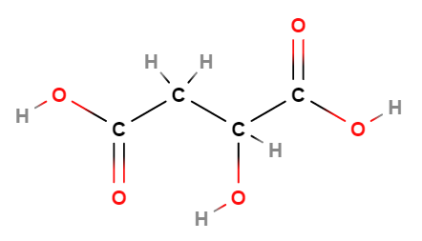

2-hydroxybutanedioic acid (malic acid)
AIM
What is the aim of this practical? [1 mark]

VARIABLES
List two controlled variables for your titration method? [2 marks]

METHOD
What is the absolute error associated with using the following pieces of scientific equipment?
[3 marks]
Burette (final titre value) ± mL
Pipette ± mL
List an additional two possible sources of error when performing a titration and label them as random or systemic? [2 marks]

Complete the following details of your method:
- Size of volumetric flask used to make solution: ____________________
- Which solution did you put in the:
Conical flask ________________________
Burette ________________________
Complete the following table to indicate what effect the following steps would have on the calculated mass of malic acid. [3 marks]
Method | Effect on calculated mass of malic acid  [Write increase mass/decrease mass/no effect]
Using water as a final wash before using the burette
Using water as a final wash before using the pipette
Using water to wash down drops of solution that had splashed up on the side of the conical flash before end-point was achieved

Which indicator did you use in your titration? With the aid of suitable equations, explain your reasoning behind this choice as a suitable indicator. [4 marks]

RESULTS AND DISCUSSION
Complete the following table for your titration. [3 marks]
Note: You DO NOT need to complete all the cells in the following table.
 | Rough titration | Accurate titrations
 |  | 1 | 2 | 3 | 4 | 5
Initial reading (mL)
Final reading (mL)
Titrate volume (mL)

Calculate the mass of malic acid in your sample (SHOW FULL WORKING). [5 marks]

9. Complete the table below. [3 marks]
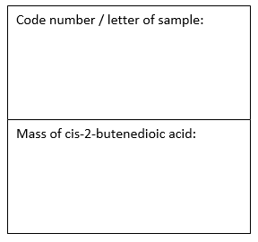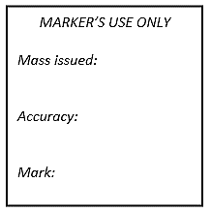
10. Calculate the percentage error of the average titre volume of your experiment. [2 marks]
Average titre volume = _________________
Percentage error =

End of Investigation

